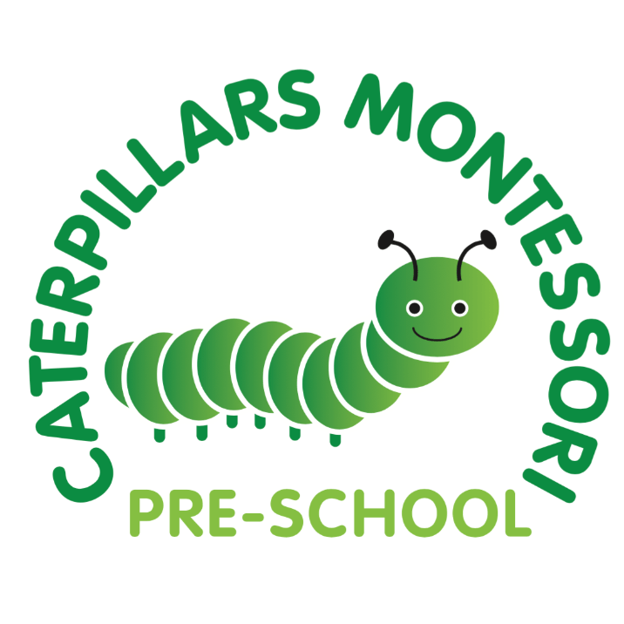
Local offer for Special educational needs and disabilities
Caterpillars Montessori Pre-school values the abilities and achievements of all individual children and is committed to providing the best possible environment for learning and development for every child.
We recognise that many people will have special needs at some point in their life. Whilst many factors contribute to the range of difficulties experienced by some children, we believe that much can be done to overcome them by working together with parents, pre-school staff, specialists and children.
Objectives of the Pre-school SEND provision
- To ensure that all children have access to a broad and balanced curriculum.
- To provide a differentiated curriculum appropriate to the individual’s needs and ability.
- To ensure the identification of all children requiring SEND provision as early as possible.
- To ensure that children with SEND take as full a part as possible in all pre--school activities and experiences.
- To ensure that parents of children with SEND are kept fully informed of their child’s progress and development.
- To ensure that children with SEND are involved, where practicable, in decisions affecting their future SEND provision.
- To liaise with outside agencies, when this would be beneficial, in order to access further specialist support for children and their families.
The main methods of provision offered by Caterpillars Montessori Pre-school are extremely flexible and we cater to the needs of the individual child as much as possible.
Please find below some examples of SEND provision used successfully at Caterpillars Montessori Pre-school:
- Individual Educational Plans (IEP’s) drawn up in partnership with parents, to provide achievable targets for an individual child. IEP’s are reviewed by the child’s key person, parents and pre-school SENCO, after approximately 6 to 8 weeks.
- Additional adults to support periods of individual or small group work.
- Adopting a ‘Graduated Approach’: a step-by-step approach where increasing levels of support are given where necessary.
- Support from specialists for specific programmes and training, for example Speech & Language Therapists or Early years Advisory Teachers.
- Additional supported transition visits to infant school.
Who to contact at Caterpillars Montessori Pre-school regarding Special Educational Needs &/or Disabilities?
If your child has a Special Educational Need &/or Disability and you would like to know more about how we could support them, please contact Angela Pagett on 01252 844706 or email angela@caterpillarspreschool.co.uk.

